Ex No: 4 – STOCK MAINTAINANCE SYSTEM NAME: ROHINI(192420054)
USE CASE DIAGRAM:

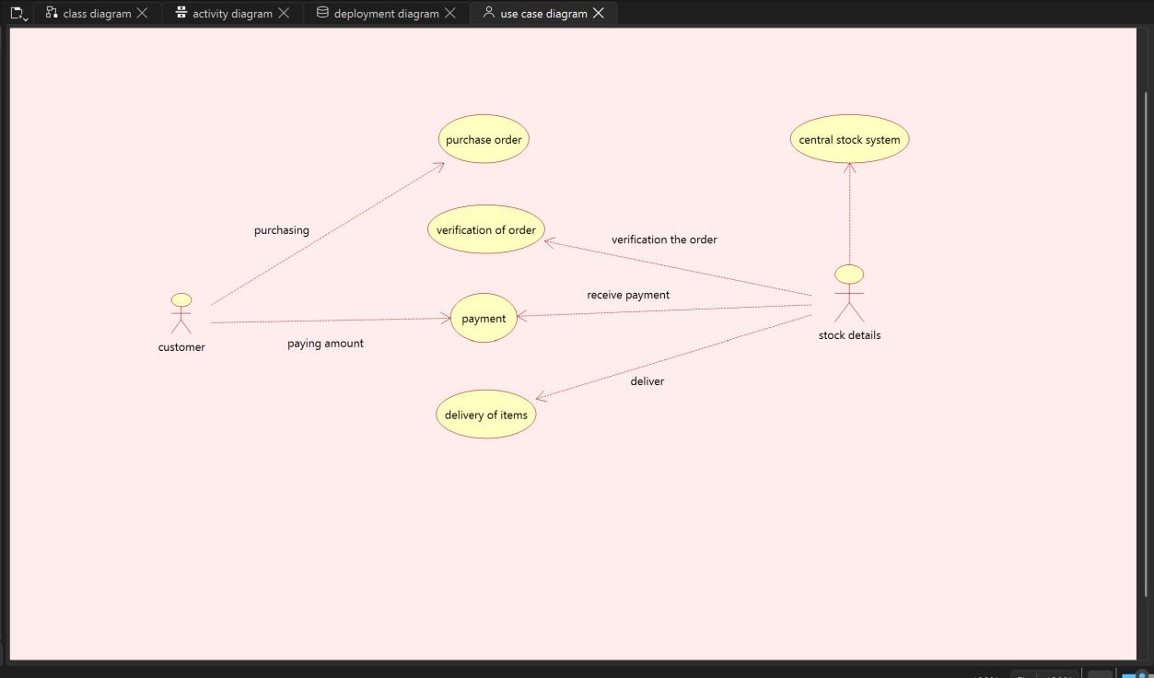

CLASS DIAGRAM:
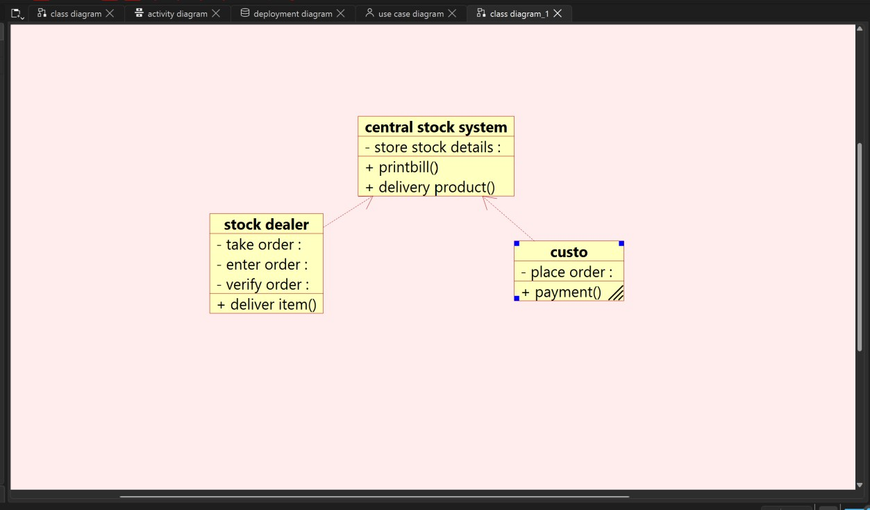

STATE CHART DIAGRAM:
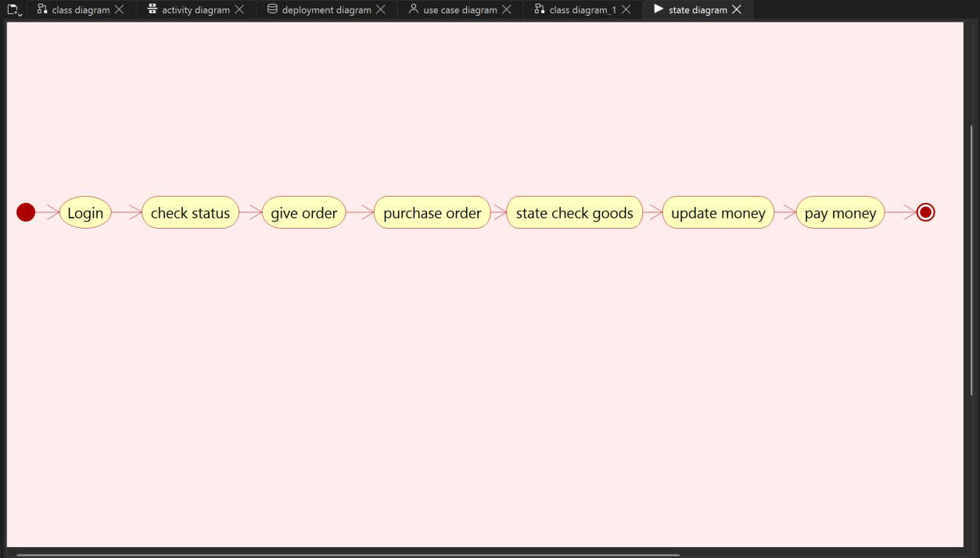

DEPLOYMENT DIAGRAM:

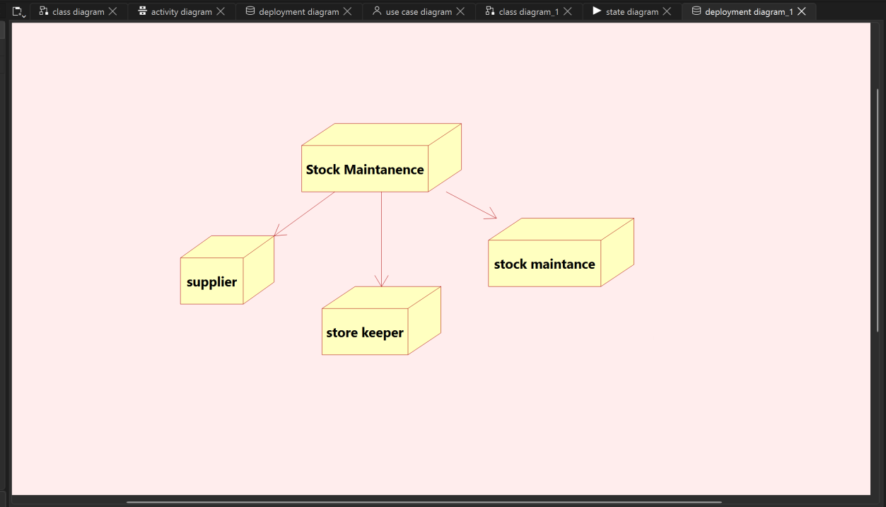

SEQUENCE DIAGRAM:

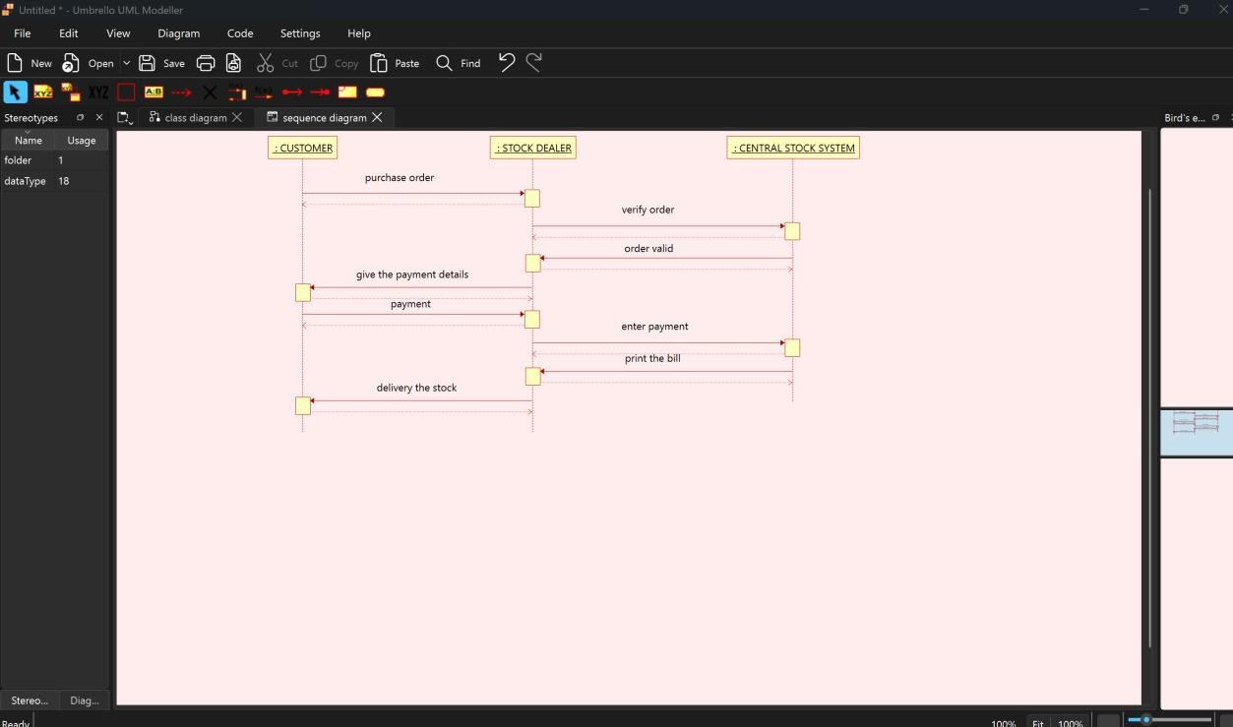

COLLABORATION DIAGRAM:
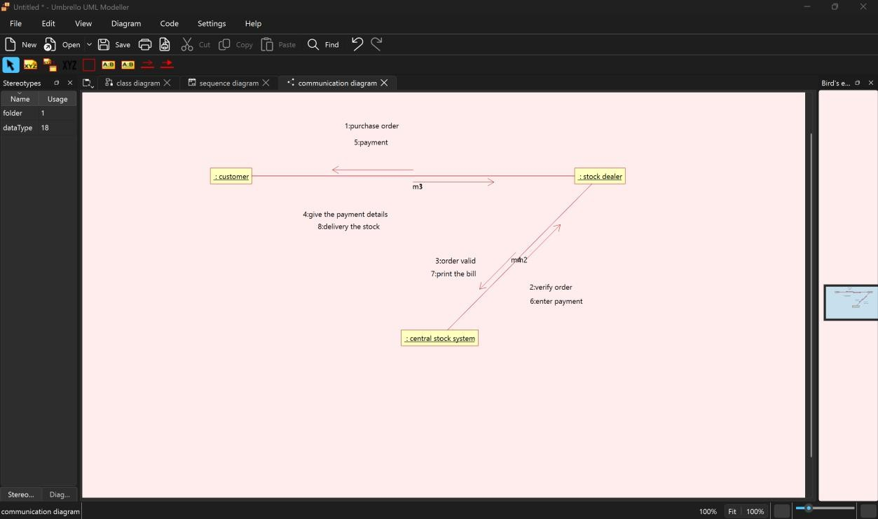

COMPONENT DIAGRAM:

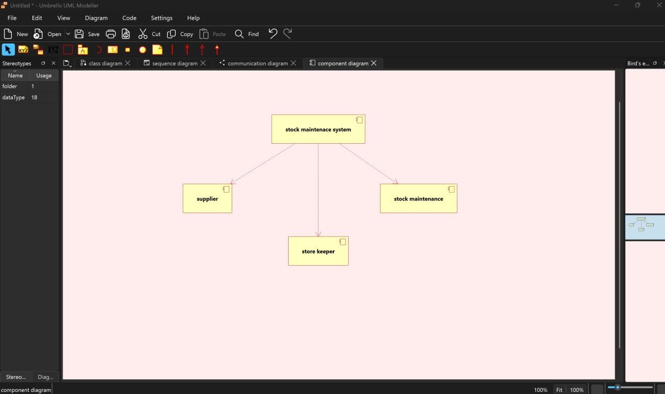

PACKAGE DIAGRAM:
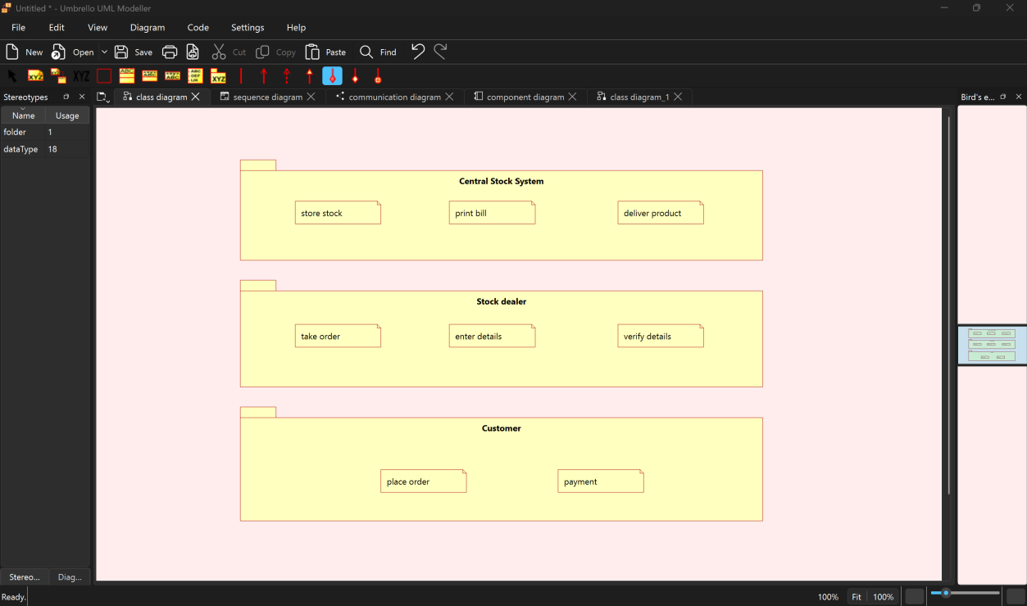

ACTIVITY DIAGRAM:
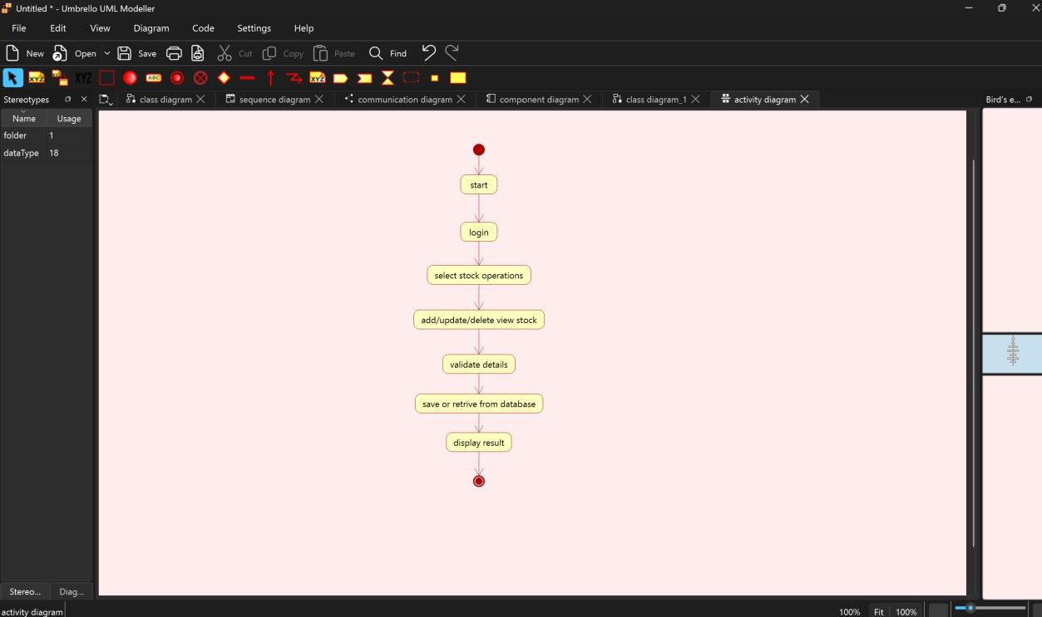

WEBPAGE FOR STOCK MANAGEMENT SYSTEM

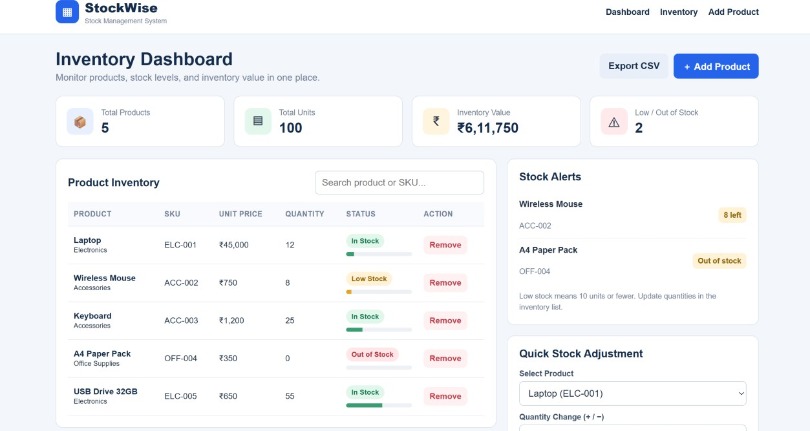

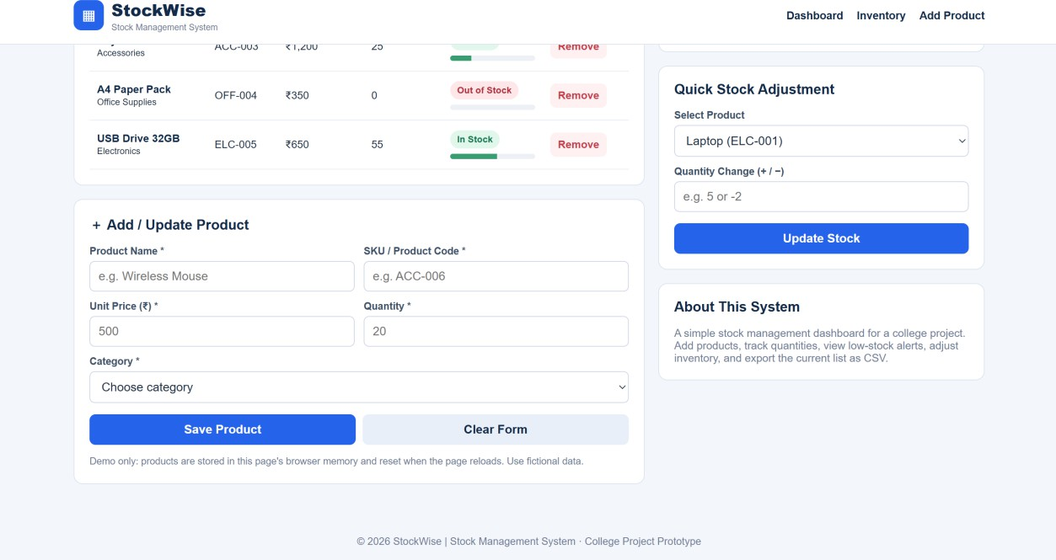

HTML CODE:

